Linux like windows os
Linux basic CMD commands

Linux commands form the core interface for interacting with the Linux operating system. They allow users to manage files, monitor system processes, and configure network settings directly through a text-based terminal.

Navigation & Directory

1. Start with Linux basics
First understand:
- What Linux is
- Linux distributions: Ubuntu, Debian, RHEL, CentOS/AlmaLinux
- Terminal vs GUI
- Filesystem structure
- Users and groups
- Root user
- Permissions
- Processes
- Services
- Networking
- Package management

2. Basic terminal commands

Whoami → who you are logged in as Check Current User
Id→ User ID (UID), Primary Group ID (GID), and all the Supplementary Groups you belong to .Check User ID Info
uname -a →Check System Info
Clear → Clear Screen

Check where you are →pwd (present working directory)

List files→ls
- ls -l Shows files with detailed information Includes size, date, permissions, owner
- ls -a → Shows all files, including hidden files Hidden files start with a dot (.)
- ls -la → Combines both options
- ls -lh →-h (Human-Readable)

Move between directories → cd
cd /home --> parent directory
cd .. --> previous directory
cd ~ -->.~ = your home directory
cd - --> main starting folder of the system
cd / --> Go to the main starting folder of the system

Create a directory → mkdir devops

Create nested directories: → mkdir devops/linux/scripts
Nested files inside folders → touch project/deom/filename.txt

Create a file
touch test.txt

View a file
cat test.txt

nano filename.txt →Edit a File

Copy
cp test.txt backup.txt
Copy a directory:
cp -r devops backup

Move / rename
mv test.txt new.txt

Delete
rm test.txt
Directory:
rmdir devops
⚠️ Be extremely careful with rm -rf.

3. Learn the Linux filesystem
You should know what these directories are used for:
/
├── bin
├── boot
├── dev
├── etc
├── home
├── lib
├── opt
├── proc
├── root
├── tmp
├── usr
└── var
Most important for DevOps:
Directory | Purpose
/etc | Configuration files
/var/log | Logs
/home | User home directories
/tmp | Temporary files
/opt | Optional/application software
/usr/bin | Programs/commands
/root | Root user's home
/var | Variable data such as logs
For example:
cd /var/log
ls -lah
This is something you'll frequently do when troubleshooting servers.

4. File searching

find
Find a file:
find /home -name test.txt
Find .log files:
find /var/log -name "*.log"
Find files by type:
find . -type f
Find directories:
find . -type d


5. Search inside files
This is very important for DevOps.

grep
grep "error" app.log
Case-insensitive:
grep -i "error" app.log
Search recursively:
grep -R "error" /var/log


You will use commands like this constantly while troubleshooting applications.

6. File permissions
You need to understand this output:
ls -l
Example:
-rwxr-xr-- 1 ubuntu ubuntu 1234 test.sh
Permissions consist of:
r = read
w = write
x = execute
Three groups:
owner | group | others
Example:
rwx | r-x | r--

chmod
Make a script executable:
chmod +x script.sh
Then:
./script.sh
Numeric permissions are important too:
chmod 755 script.sh
chmod 644 file.txt
Know these common ones:
755 → rwxr-xr-x
644 → rw-r--r--
600 → rw-------
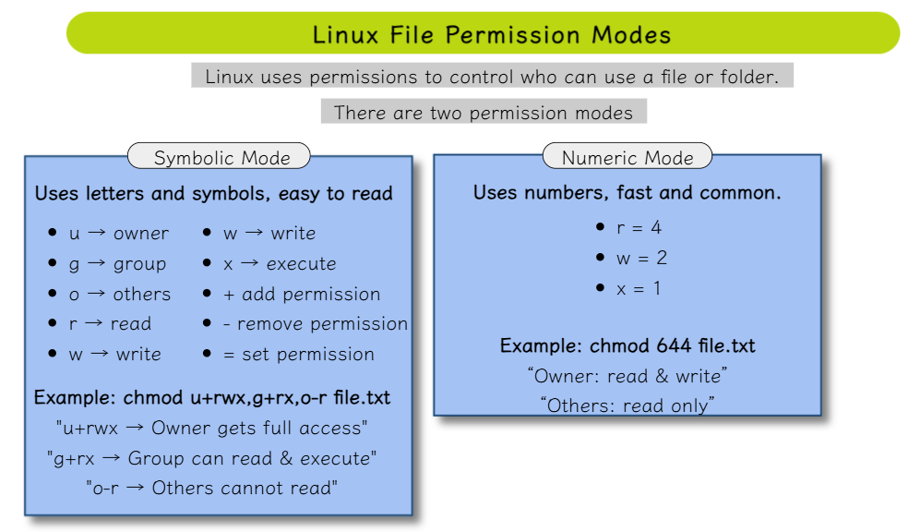

7. Users and groups
Check current user:
whoami
Check user information:
id
List users:
cat /etc/passwd
Create a user:
sudo useradd devops
Set password:
sudo passwd devops
Create a group:
sudo groupadd developers
Add user to group:
sudo usermod -aG developers devops


8. sudo
sudo allows an authorized user to execute commands with elevated privileges.
Example:
sudo apt update
You'll see sudo everywhere in DevOps.
Don't blindly use:
sudo rm -rf ...
Understand the command before executing it.

Package Management Commands and Process Management Commands in Linux

Package & Process Management with Networking Commands (apt, yum, netstat, ping, curl)
Software must be installed→ ​Network must be available →Both are managed by system tools

Linux systems usually run on servers without a screen or mouse. So software installation and network checking are done using commands.

Let’s now understand
How Linux manages software and network communication.

What is a Software Package?
A software package is a ready-made application. Example idea: browser, tools, utilities.

It allows Linux to install software quickly and safely.

Understanding Package Management
Package management is the system used to install, update, and remove software in Linux.

9. Package management
Package management is the system used to install, update, and remove software in Linux.
Apt(Advanced Package Tool) → Used in Ubuntu / Debian
yum → (Yellowdog Updater Modified) is Used on CentOS, Red Hat, Amazon Linux.
If you're using Ubuntu/Debian: These commands act like an App Store for Linux.
sudo apt update
sudo apt upgrade
Install software:
sudo apt install nginx
Remove:
sudo apt remove nginx
Check whether something is installed:
dpkg -l | grep nginx


10. Processes
A DevOps engineer needs to know how to find and troubleshoot processes.
Kitchen = Linux system
Chefs = Running programs (processes)
Linux systems run many programs at the same time.
To keep the system fast and stable, Linux must monitor and control these programs.
Let’s understand → how Linux manages running programs using process management.

What is a Process?
A process is a program that is currently running. Every time you run a command or application, a process starts. Example: browser, server, background task.
Why Process Management is Important
Process management helps to
- Keep the system fast,
- Avoid system crashes, ​
- Control resource usage.
Without process management, systems can slow down or fail.

ps
ps -->View running processes
More useful:
ps aux
Search for a process:
ps aux | grep nginx

top
top -->top command shows live system activity and running processes
You can see:
- CPU usage
- Memory usage
- Processes
- Process IDs
Also learn:
htop
if available.
Stopping a Process → Linux allows users to stop such programs safely. Sometimes a program Freezes, Uses too much memory,Stops responding

Kill a process →Stop a running process
kill PID
Example:
kill 1234
Force kill:
kill -9 1234
Don't use kill -9 as your first choice; try a normal termination first.
nohup → Run process in background
crontab → Schedule tasks automatically
These commands help manage long-running tasks.

11. Services
This is very important for DevOps.
Modern Linux systems commonly use systemd.
Check a service:
systemctl status nginx
Start:
sudo systemctl start nginx
Stop:
sudo systemctl stop nginx
Restart:
sudo systemctl restart nginx
Enable at boot:
sudo systemctl enable nginx
Disable:
sudo systemctl disable nginx
You'll frequently troubleshoot situations like:
"The application is not working."
You might check:
systemctl status nginx
and then inspect logs.

12. Logs (Log Management & Monitoring)

Log Commands (top, Free, Iostat, Df, Ps, Uptime)
Log monitoring commands work like a system activity dashboard.
To understand system activities clearly, Linux provides commands that show activity details in output form.

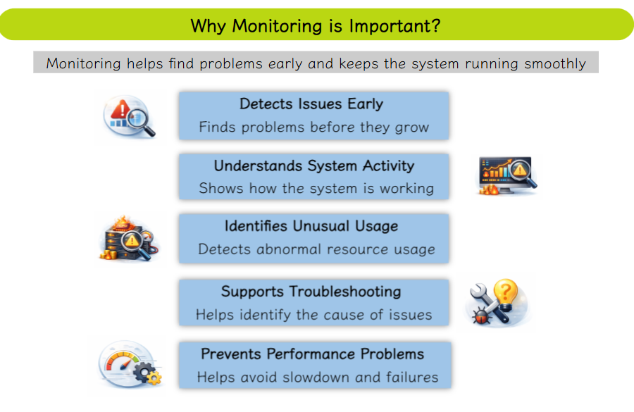
What is Log Management?
Logs are records of system activities They store information about: What happened When it happened Which service or process was involved.
Logs help us understand past system events

logs show when the error happened and what caused it,
Log management helps find issues and fix problems faster
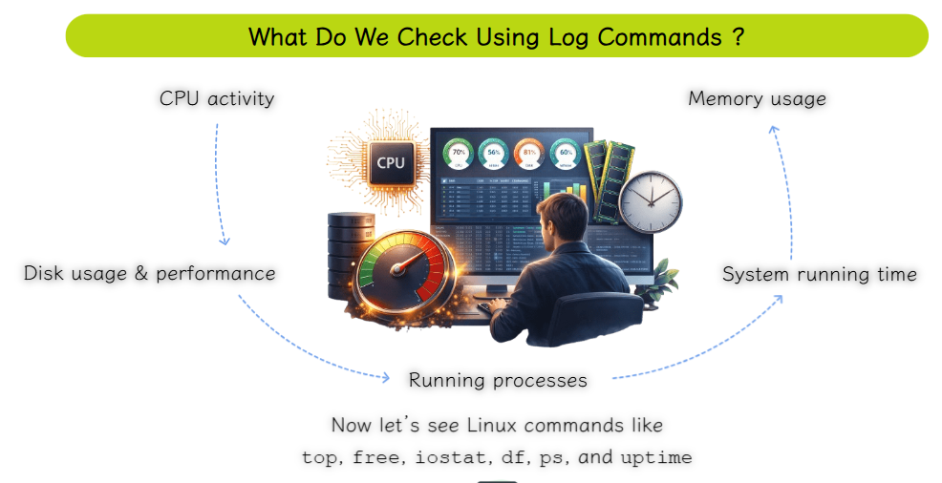
- top command shows live system activity and running processes
- The free command is used to check memory usage free -h human-readable format(-m →mb, -g→gb)
- The iostat command is used to monitor CPU and disk Input/output performance(“It helps identify disk and CPU bottlenecks”)
- The df command is used to check disk space usage -h
- The ps command is used to view running processes (ps -e → shows all running processes ps -A → shows all processes (same as -e))
- The uptime command is used to check how long the system has been running
Logs store system activity records
Logs help understand what happened earlier
Now we will learn how to read and search logs
Log Management & Monitoring →Monitoring Commands (tail, grep, journalctl, syslog)
we use monitoring commands.These commands help us to
view current status, track activity, identify problems quickly
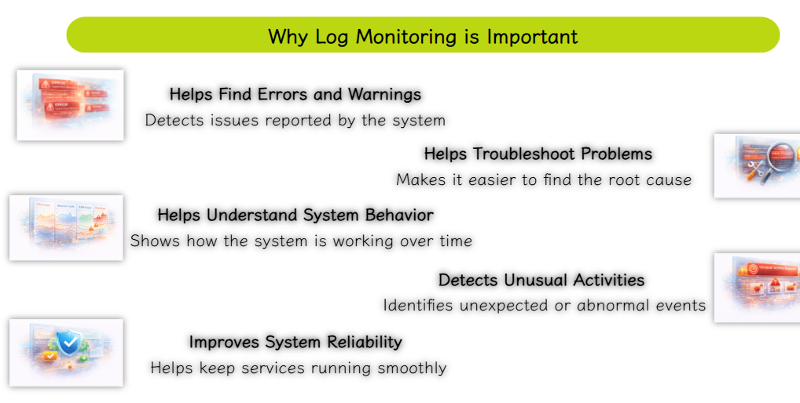
What is Log Monitoring?
Log monitoring means reading and checking log messages to understand system events, errors, and activities.
Logs record details about what happened, when it happened, and sometimes why it happened.
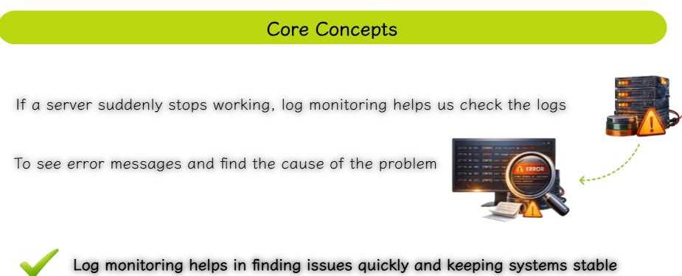
- The tail Command Shows the last part of a log file to check recent activity.(“It helps monitor logs in real time”)
- grep is a command used to search specific text or patterns inside files, mainly log files. “It helps quickly find important information.”
- The journalctl command displays system logs collected by services. “It helps troubleshoot system and service issues.”
- Syslog stores system and service log messages using a logging service “It helps centralize and manage logs.”
Learn these commands well:
ls /var/log
View logs:
cat /var/log/syslog
Search:
grep "error" /var/log/syslog
Watch logs live:
tail -f /var/log/syslog
For systemd services:
journalctl -u nginx
Live:
journalctl -u nginx -f
This is a real DevOps skill, not just a Linux interview topic.

13. Disk management
Check disk space:
df -h
Check directory size:
du -sh /var/log
Find large directories:
du -sh /var/* 2>/dev/null
A common production problem is:
"Server is running out of disk space."
You should know how to investigate it.

14. Memory and CPU
Memory:
free -h
CPU/processes:
top
System information:
uname -a
CPU information:
lscpu
Memory information:
cat /proc/meminfo


15. Networking — extremely important
Why Networking is Important
Networking allows Linux systems to:
- Connect to the internet
- Communicate with other servers
- Access websites and services
Without networking, servers cannot function properly.
Networking Commands :These commands help verify system communication.
- curl → Access web service Linux provides commands to check network communication:
- ping → Check connectivity
- netstat → View network activity
Learn these commands:
ip addr
See routes:
ip route
Test connectivity:
ping google.com
DNS lookup:
nslookup google.com
or:
dig google.com
Check listening ports:
ss -tulnp
Test an HTTP endpoint:
curl http://localhost
Download something:
curl -O https://example.com/file.txt
You should eventually understand:
IP
Port
DNS
TCP
HTTP/HTTPS
SSH
Firewall


16. SSH
This is essential because DevOps engineers commonly work with remote servers.
Connect:
ssh username@server-ip
Example:
ssh ubuntu@10.10.10.20
Copy a file:
scp test.txt ubuntu@10.10.10.20:/home/ubuntu/
Copy a directory:
scp -r project ubuntu@10.10.10.20:/home/ubuntu/
Later you'll learn SSH keys:
your laptop
|
| SSH
↓
Linux server


17. Pipes and redirection
This is where Linux becomes powerful.

Pipe |
ps aux | grep nginx
Output from one command becomes input to another.

>
ls > files.txt
Write output to a file.

>>
echo "hello" >> log.txt
Append to a file.

2>
Redirect errors:
command 2> error.log

Combine
cat app.log | grep ERROR | tail -20
You don't need to memorize complicated commands. Understand how commands can be chained.

18. Useful text commands
Learn:
grep
awk
sed
cut
sort
uniq
wc
head
tail
Examples:
cat app.log | grep ERROR

cat users.txt | sort

cat file.txt | wc -l
These become especially useful in shell scripting and troubleshooting.

19. Environment variables
Check:
env
Check a specific variable:
echo $PATH
Create one:
export APP_ENV=production
Check:
echo $APP_ENV
This becomes very important with:
- Docker
- Kubernetes
- CI/CD
- Applications
- Cloud deployments

20. Shell scripting
Once you're comfortable with commands, start Bash scripting.
Create:
script.sh
Example:
#!/bin/bash

echo "Hello DevOps"
echo "Current user: $(whoami)"
echo "Current directory: $(pwd)"
Make executable:
chmod +x script.sh
Run:
./script.sh
Then learn:
Variables
if/else
for loops
while loops
functions
arguments
exit codes
conditions


Your first DevOps practice project
Don't just read commands. Practice them.
Create a Linux VM using something like Ubuntu and perform this exercise:
mkdir devops
cd devops

mkdir scripts logs backups

touch app.log
echo "Application started" > app.log
echo "ERROR: Database connection failed" >> app.log

cat app.log

grep "ERROR" app.log

cp app.log backups/app.log

ls -lah

du -sh .

chmod 755 scripts
Then install Nginx:
sudo apt update
sudo apt install nginx
Check it:
systemctl status nginx
Test it:
curl http://localhost
Find the process:
ps aux | grep nginx
Check listening ports:
ss -tulnp
View logs:
journalctl -u nginx
At this point, you're already doing basic real-world Linux administration.

Project2. Install System Dependencies & Setup CartForge Environment

- Update System (Ubuntu - APT)
sudo apt update
sudo apt upgrade -y

- Install Required Packages (APT)

sudo apt install git -y
sudo apt install nodejs -y
sudo apt install npm -y
- Verify Installations
git --version
node -v
npm -v

- Clone CartForge Project
git clone https://github.com/mantu0tech/cartforge.git
cd cartforge

- Service Commands (Important)
- Start Service →sudo systemctl start nginx
- Stop service → sudo systemctl stop nginx
- Restart service → sudo systemctl restart nginx
- Check Status
sudo systemctl status nginx

- Enable Service (Auto Start)
sudo systemctl enable nginx

Task 2: Monitor Server Performance & System Health Metrics

“We need continuous monitoring to keep the system healthy.”

CPU usage Memory usage Disk space Running processes

- Real-time CPU & Memory
Top
Press q to exit
htop
- Memory Usage
free -h
- CPU Info
Lscpu
- System Load
Uptime
- Disk Usage (Disk Space)
df -h
- Folder Size (inside project folder)
du -sh *
- Running Processes
ps -ef
- Search Specific Process
ps -ef | grep nginx
- Open Ports (If not installed the install it)
sudo apt install net-tools
sudo netstat -tulnp

- Check IP Address
ip a

Task 3: Automate Maintenance & Resolve Performance Issues

Instead of reacting to problems, we will prevent them using automation.”
“We’ll create scheduled tasks that keep the system clean and healthy.

- Open Crontab
crontab -e
- Common Automation Tasks
0 0 * * * rm -rf /home/ubuntu/cartforge/logs/*.log

- Restart Application Daily
0 2 * * * systemctl restart nginx
- Backup Project Folder
0 1 * * * tar -czf /home/ubuntu/backups/cartforge-$(date +\%F).tar.gz /home/ubuntu/cartforge

- Save & Exit
Press CTRL + X
- Press Y
- Press Enter

- View Cron Jobs
crontab -l
- Remove Cron Jobs
crontab -r

================================================
================================================
After Shell scripting
Project3. Log Monitoring and Troubleshooting for CartForge Ubuntu Server

After automation and monitoring are in place, the CartForge system becomes stable and efficient.

One day, unexpected issues appear:
Some features fail randomly, users face intermittent errors, and no alerts are triggered.
Everything looks normal on the surface, but hidden problems exist underneath.

The Junior DevOps Engineer gathers the team and explains:
“Monitoring tells us what is happening, but logs tell us why it is happening.”
“We’ll start analyzing logs to identify errors, failures, and unusual patterns.”

Task 1: Analyze CartForge Logs for Errors & Failures

- View Last Logs
tail /var/log/auth.log

- Live Logs
tail -f /var/log/dmesg

- Using less
less /var/log/dmesg
- Find Errors
grep "error" /var/log/syslog

- Ignore Case
grep "error" /var/log/syslog

- Real DevOps Combo
tail -f logs/app.log | grep error

- Service Logs
journalctl -u nginx

- Live Logs
journalctl -u nginx -f

- Last 50 Logs
journalctl -b -f

Task 2: Monitor Real-Time Metrics & Optimize Performance
The manager calls the Junior DevOps Engineer and explains:
“Our system is stable now, but performance is inconsistent.”He continues:
“Users expect fast responses, but during peak time, the application slows down.”
“We need to continuously monitor real-time metrics and optimize performance.”

“Now we move from stability to performance optimization.”
“We’ll monitor real-time metrics and take actions to improve system speed and efficiency.”

- CPU & Memory (Live View)
Top
- Memory Usage
free -h
- System Load
Uptime
- Disk Usage
df -h
- Folder Size
du -sh *
- Check Running Processes
ps -ef | grep nginx
Ps
Kill -9 2654



